API Automation Tool:

1. Assertible

a. <https://assertible.com/blog/automated-api-testing-with-jenkins>

b. <https://assertible.com/blog/4-techniques-to-reduce-api-testing-errors-and-improve-your-qa-automation>

c. It can be integrarted with jenkins

d. Pricing:

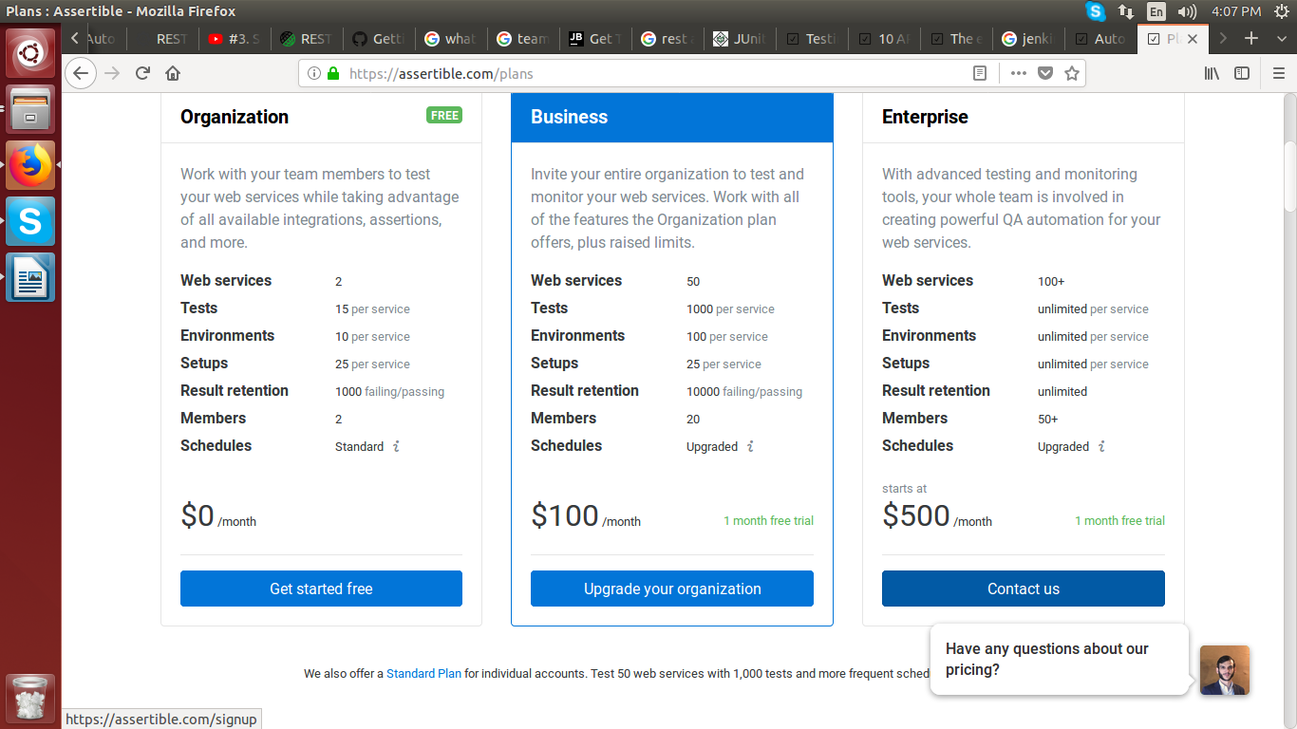

REST Assured

REST Assured is a Java DSL for simplifying testing of REST based services built on top of HTTP Builder.

1. Language: Java

2. IDE: IntelliJ

3. Test Automation framework: Data driven (Data can be given through excel sheets)

Testing framework: TestNG

4. [https://github.com/rest-assured/rest-assured/wiki/GettingStarted#non-maven-users](https://github.com/rest-assured/rest-assured/wiki/GettingStarted" \l "non-maven-users)

5. Add the following dependency to your pom.xml:

Includes [JsonPath](https://github.com/rest-assured/rest-assured/wiki/GettingStarted" \l "jsonpath) and [XmlPath](https://github.com/rest-assured/rest-assured/wiki/GettingStarted" \l "xmlpath)

Maven:

<dependency>

<groupId>io.rest-assured</groupId>

<artifactId>rest-assured</artifactId>

<version>3.1.0</version>

<scope>test</scope>

</dependency>

Gradle:

testCompile 'io.rest-assured:rest-assured:3.1.0'

Notes

1. You should place rest-assured before the JUnit dependency declaration in your pom.xml / build.gradle in order to make sure that the correct version of Hamcrest is used.
2. REST Assured includes JsonPath and XmlPath as transitive dependencies

SoapUI

1. Swagger integration

<https://www.soapui.org/extension-plugins/bundled.html>

2.